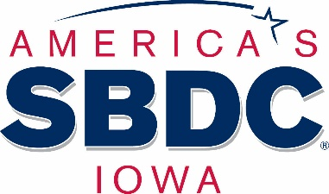

Success Story

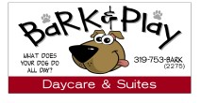

Bark & Play Dog Daycare & Suites was established in 2014 by Ann March. She was working long hours and found it difficult to find someone to care for her dog. She decided to open a dog daycare, and has since added additional services including boarding suites, in-house dog baths, and even homemade dog treats. The business recently added a Bark Bus service that will pick-up and deliver dogs from daycare, boarding or bath services.

In the past five years, Ann has increased staff to 11 employees and has strong sales. She has purchased the building she previously rented and built an addition for a play area and more boarding suites. Ann also takes time to give back to the community in many ways, including sponsoring food and fundraising drives for the Des Moines County Humane Society and Paws No-Kill Shelter. She also led a CPR/first aid class for the area K9 law enforcement dogs.

Ann met with Janine Clover, Regional Director of the Southeastern SBDC, to work on her business plan and financial projections. She found a location to rent, but it needed repairs and updates. She also needed play equipment, kennels and dog beds for her business. Janine urged Ann to enter the Des Moines County Business Plan Contest and to visit a local bank for the remaining funds needed. Ann entered the contest and won second place. With her prize money and a loan from the bank, she went to work to refurbish the space and purchase the items she needed to open the doors in August of 2014.

Ann recently participated in the first Goldman Sachs 10,000 Small Businesses cohort. A client of the SBDC since 2014, she has utilized the financial projections, business plan and QuickBooks learning services offered by the center through each stage of growth. She has attended workshops and Solopreneur events sponsored by the Southeastern SBDC.

Ann had to say of working with the Southeastern SBDC, “Thank you for all your help and continued support. Janine and the SBDC are a great resource for small businesses!”

Bark & Play Dog Daycare & Suites received the America’s SBDC Iowa Small Business of the Award in August 2019. They also received the 2017 Small Business of the Year Award from the Greater Burlington Partnership.

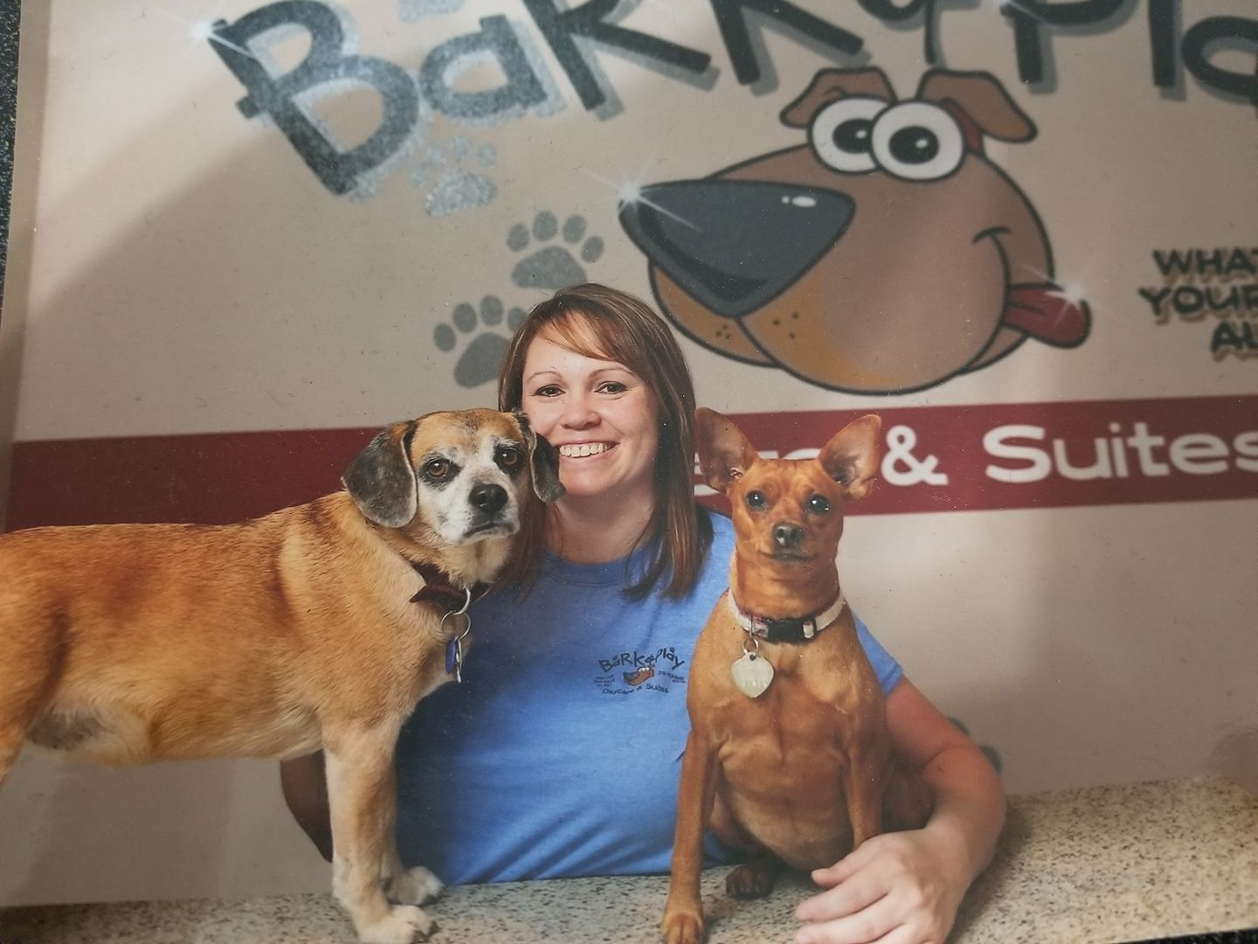

Bark & Play Dog Daycare & Suites owner Ann March, with Daisy and Luci



@barkplay



Barkandplaydaycareandsuites.com