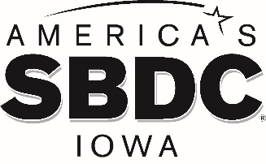

FOR IMMEDIATE RELEASE

AMERICA’S SBDC IOWA ANNOUNCES 2021 THINK BIG ENTREPRENEUR AWARD WINNER
Rebecca Runyon, Bessie’s Parlor, Ames

AMES, Iowa – America’s SBDC Iowa (SBDC) is pleased to announce that Rebecca Runyon, Founder, Bessie’s Parlor, is the 2021 Think Big Award winner.
The Think Big Award recognizes an up and coming entrepreneur who has displayed extraordinary potential on their entrepreneurial journey. This award is given to an individual who not only develops their own business ideas, but encourages others to participate in the entrepreneurial ecosystem in Iowa.
Dave Biedenbach, Regional Director of the Iowa State University SBDC, nominated Runyon for the Think Big Award because, “Rebecca has and continues to demonstrate her entrepreneurial spirit and determination and is always willing to help and advocate for women-owned businesses and young entrepreneurs in our growing ecosystem.”
Runyon will be presented her award during a ceremony on June 10 at 1:30 PM at the ISU Economic Development Core Facility (1805 Collaboration Place, Ames).
For additional information about the award winners:

Rebecca Runyon, Bessie’s Parlor: http://bessiesparlor.com/

America’s SBDC Iowa is an outreach program of Iowa State University’s Ivy College of Business and the Office of Economic Development and Industry Relations. Iowa State University does not discriminate on the basis of race, color, age, ethnicity, religion, national origin, pregnancy, sexual orientation, gender identity, genetic information, sex, marital status, disability, or status as a U.S. Veteran. Inquiries regarding non-discrimination policies may be directed to the Office of Equal Opportunity, 3410 Beardshear Hall, 515 Morrill Road, Ames, Iowa 50011, Tel. 515-294-7612, Hotline 515-294-1222, email eooffice@iastate.edu.

Funded in part through a cooperative agreement with the U.S. Small Business Administration, America’s SBDC Iowa has 15 regional assistance centers located strategically across the state. Since program inception in 1981, the SBDC has helped Iowa businesses and entrepreneurs through no fee, confidential, customized, professional business counseling and practical, affordable training workshops.

For more information on America’s SBDC Iowa programs or services, call (515) 294-2030 or visit www.iowasbdc.org, or on social media @IowaSBDC.

Press Contacts:
Brianna Hall, America’s SBDC Iowa, 515-294-2030, bschwind@iastate.edu
Lisa Shimkat, America’s SBDC Iowa, 515-294-2030, lshimkat@iastate.edu

PHOTO
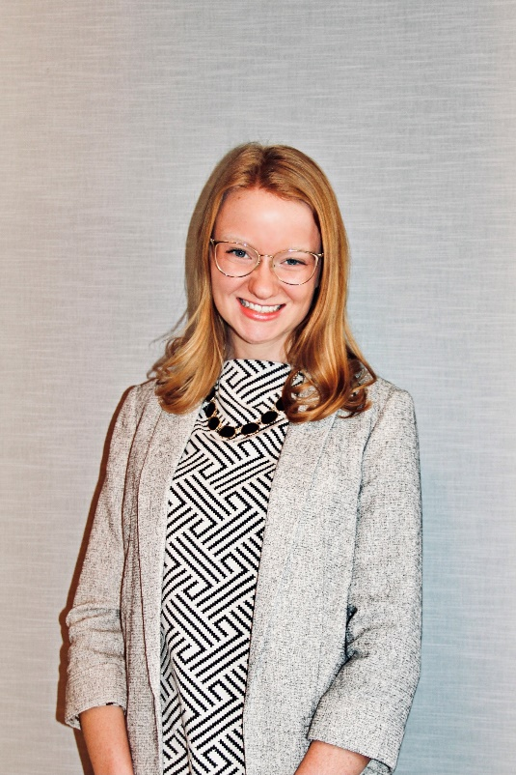
Rebecca Runyon
Founder, Bessie’s Parlor

