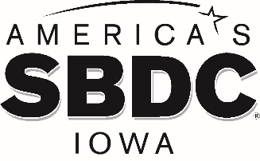

FOR IMMEDIATE RELEASE

America’s SBDC Iowa’s Amy Dutton Becomes Certified Exit Planning Advisor
Regional Director at University of Northern Iowa SBDC becomes CEPA

AMES, Iowa - America’s SBDC Iowa (SBDC) is pleased to announce that Amy Dutton, Regional Director of the University of Northern Iowa SBDC, Cedar Falls, has achieved certification in the Certified Exit Planning Advisor (CEPA) program.

The Certified Exit Planning Advisor (CEPA) Program is an executive MBA-style program that trains and certifies qualified professional advisors in the field of exit planning. The CEPA Program integrates exit strategy into business, personal, and financial goals of the business owner. The program focuses on enterprise value as well as a common language for all parties from all specialties navigating the exit planning conversation.

Dutton has been counseling businesses in Black Hawk, Bremer, Buchanan, Butler, Chickasaw, Fayette, Grundy, Howard and Tama counties since October 2016.

Lisa Shimkat, SBDC State Director, says, “Amy is a valuable member of our statewide team. She is dedicated to giving SBDC clients sound business advice and connecting them with resources they need to succeed – at all stages of their business. This certification is challenging to obtain and will provide Amy with additional knowledge that she can pass along to benefit those she advises.”

More information about the Certified Exit Planning Advisor Program can be found at https://exit-planning-institute.org/program/certified-exit-planning-advisor/.

America’s SBDC Iowa is an outreach program of Iowa State University’s Ivy College of Business and the Office of Economic Development and Industry Relations. Iowa State University does not discriminate on the basis of race, color, age, ethnicity, religion, national origin, pregnancy, sexual orientation, gender identity, genetic information, sex, marital status, disability, or status as a U.S. Veteran. Inquiries regarding non-discrimination policies may be directed to the Office of Equal Opportunity, 3410 Beardshear Hall, 515 Morrill Road, Ames, Iowa 50011, Tel. 515-294-7612, Hotline 515-294-1222, email eooffice@iastate.edu.

Funded in part through a cooperative agreement with the U.S. Small Business Administration, America’s SBDC Iowa has 15 regional assistance centers located strategically across the state. Since program inception in 1981, the SBDC has helped Iowa businesses and entrepreneurs through no fee, confidential, customized, professional business counseling and practical, affordable training workshops.

For more information on America’s SBDC Iowa programs or services, call (515) 294-2030 or visit www.iowasbdc.org or www.facebook.com/AmericasSBDCIowa.

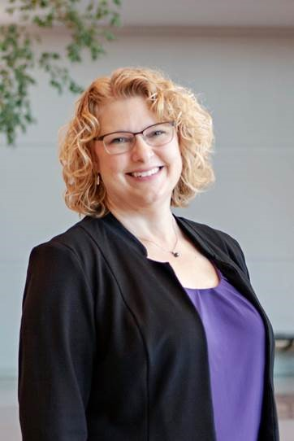

Amy Dutton, CBA, CEPA
University of Northern Iowa SBDC Regional Director

Press Contacts:
Brianna Hall, America’s SBDC Iowa, 515-294- 2030, bschwind@iastate.edu
Lisa Shimkat, America’s SBDC Iowa, 515-294-2030, lshimkat@iastate.edu

###

