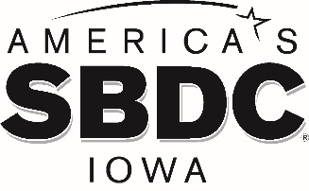

FOR IMMEDIATE RELEASE

June 24, 2021

AMERICA’S SBDC IOWA ANNOUNCES RECIPIENT OF NATIONAL AWARD
Brook Boehmler to be honored as America’s SBDC Iowa State Star

AMES, Iowa – Brook Boehmler, Regional Director of the North Iowa Area Small Business Development Center in Mason City, has been named the 2021 Iowa State Star by the national Small Business Development Center (SBDC) association, America’s SBDC.
America’s SBDC annually recognizes SBDC personnel for demonstrating exemplary work performance, significantly contributing to the organization’s economic development efforts, and showing a strong commitment to small businesses.
“Brook is a true advocate for small business across our state,” says Lisa Shimkat, America’s SBDC Iowa State Director. “His contributions to the SBDC and our small businesses have been significant, including developing strong relationships with key stakeholders, increasing marketing for his center, and working tirelessly to helping others succeed. We are honored to have Brook in our network.”
Boehmler has been the Regional Director of the North Iowa Area SBDC since 2014.
America’s SBDC Iowa is an outreach program of Iowa State University’s Ivy College of Business and the Office of Economic Development and Industry Relations. Iowa State University does not discriminate on the basis of race, color, age, ethnicity, religion, national origin, pregnancy, sexual orientation, gender identity, genetic information, sex, marital status, disability, or status as a U.S. Veteran. Inquiries regarding non-discrimination policies may be directed to the Office of Equal Opportunity, 3410 Beardshear Hall, 515 Morrill Road, Ames, Iowa 50011, Tel. 515-294-7612, Hotline 515-294-1222, email eooffice@iastate.edu.

Funded in part through a cooperative agreement with the U.S. Small Business Administration, America’s SBDC Iowa has 15 regional assistance centers located strategically across the state. Since program inception in 1981, the SBDC has helped Iowa businesses and entrepreneurs through no fee, confidential, customized, professional business counseling and practical, affordable training workshops.

For more information on America’s SBDC Iowa programs or services, call (515) 294-2030 or visit www.iowasbdc.org, https://www.facebook.com/AmericasSBDCIowa, or https://twitter.com/IowaSBDC.

Press Contacts:
Stacy Dreyer, America’s SBDC Iowa, 515-294-5595, sdreyer@iastate.edu
Lisa Shimkat, America’s SBDC Iowa, 515-294-2030, lshimkat@iastate.edu

PHOTO
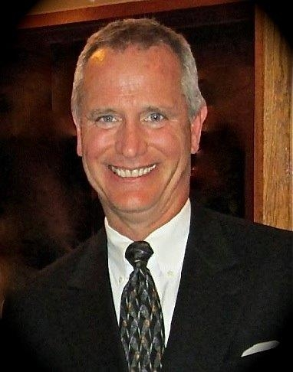

Brook Boehmler, Regional Director, North Iowa Area SBDC
America’s SBDC Iowa State Star

