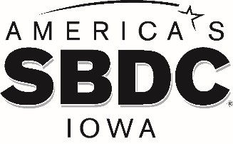

FOR IMMEDIATE RELEASE

December 15, 2020

AMERICA’S SBDC IOWA ANNOUNCES NEW REGIONAL DIRECTOR FOR SOUTH CENTRAL IOWA SBDC AT SOUTHWEST COMMUNITY COLLEGE
Jamie David is the new Regional Director for the South Central Iowa SBDC

AMES, Iowa – America’s SBDC Iowa (SBDC) is pleased to announce that Jamie David is the new Regional Director for the South Central Iowa Small Business Development Center (SBDC) in Creston, which is hosted by Southwest Community College. She started her new position on January 11, 2021.

David will be advising and training entrepreneurs and existing business owners in Adair, Adams, Clarke, Decatur, Madison, Montgomery, Ringgold, Taylor and Union counties.

“America’s SBDC Iowa is pleased to add Jamie David to our team of knowledgeable, experienced, and professional business advisors,” says SBDC State Director Lisa Shimkat. “She brings years of accounting experience to our organization, plus valuable experience as a small business owner and operator. She will build on our strong connections with area resource partners and encourage new business growth in her southwest Iowa region.”

In addition to owning and operating her own small business with her husband for the past six years, David has over 15 years of accounting experience working in both large and small businesses. David is currently serving her second four-year term as an Iowa State Extension & Outreach council member in Taylor county and is a state board member on the Iowa Extension Council Association for her region. She was also a 2019 Iowa Graduate of the Goldman Sachs 10,000 Small Businesses Program.

America’s SBDC Iowa is an outreach program of Iowa State University’s College of Business and
the Office of Economic Development and Industry Relations. Iowa State University does not

discriminate on the basis of race, color, age, ethnicity, religion, national origin, pregnancy, sexual orientation, gender identity, genetic information, sex, marital status, disability, or status as a U.S. veteran. Inquiries regarding non-discrimination policies may be directed to the Office of Equal Opportunity, 3410 Beardshear Hall, 515 Morrill Road, Ames, Iowa 50011, Tel. 515-294- 7612, email eooffice@iastate.edu.

Funded in part through a cooperative agreement with the U.S. Small Business Administration, America’s SBDC Iowa has 15 regional assistance centers located strategically across the state. Since program inception in 1981, the SBDC has helped Iowa businesses and entrepreneurs through no fee, confidential, customized, professional business counseling and practical, affordable training workshops.

For more information on America’s SBDC Iowa programs or services, call (515) 294-2030 or visit www.iowasbdc.org, https://www.facebook.com/AmericasSBDCIowa, or https://twitter.com/IowaSBDC.

Press Contacts:
Brianna Hall, America’s SBDC Iowa, 515-294-2030, bschwind@iastate.edu
Jamie David, South Central Iowa SBDC, 641-782-1483, David@swcciowa.edu

PHOTO

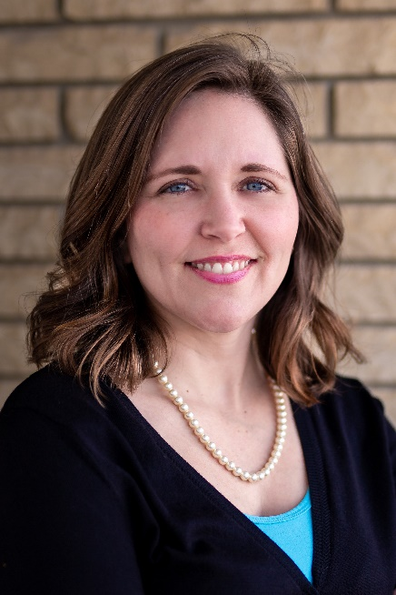
Jamie David, Regional Director at South Central Iowa SBDC

