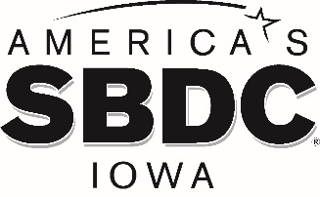

FOR IMMEDIATE RELEASE

DATE

AMERICA’S SBDC IOWA STATE DIRECTOR RECEIVES CYTATION AWARD FROM IOWA STATE UNIVERSITY

AMES, Iowa – America’s Small Business Development Center Iowa (SBDC) is pleased to share that Lisa Shimkat, State Director, has received the Iowa State University (ISU) Professional and Scientific Council CYtation Awards. The award recognizes ISU employees that do something above and beyond the call of duty, and acts in such a way as to make a very real difference in the institution.
Lisa was nominated by SBDC State Office staff for her leadership in directing the organization and uplifting small business owners during the COVID-19 pandemic. Because of her strong leadership and visionary efforts, SBDC has been able to deliver significant and timely resources to nearly 70,000 small businesses since the pandemic began. SBDC has established and strengthened statewide relationships and are seen as a national leader. Lisa has worked tirelessly with statewide partners, stakeholders and staff to get them involved in helping small businesses that are in crisis.
“Lisa has been instrumental in leading our organization throughout the COVID-19 pandemic,” says SBDC Associate State Director Stacy Dreyer. “Her determination and creativity have made a huge difference. She supports our statewide team of 15 regional centers, and keeps pushing us to reach new heights. Her passion for small business success in Iowa is relentless and impactful.”
Information about the CYtation Awards can be found at: https://www.pscouncil.iastate.edu/awards/2020-cytation-recipients.
America’s SBDC Iowa is an outreach program of Iowa State University’s Ivy College of Business and the Office of Economic Development and Industry Relations. Iowa State University does not discriminate on the basis of race, color, age, ethnicity, religion, national origin, pregnancy, sexual orientation, gender identity, genetic information, sex, marital status, disability, or status as a U.S. Veteran. Inquiries regarding non-discrimination policies may be directed to the Office of Equal Opportunity, 3410 Beardshear Hall, 515 Morrill Road, Ames, Iowa 50011, Tel. 515-294-7612, Hotline 515-294-1222, email eooffice@iastate.edu.

Funded in part through a cooperative agreement with the U.S. Small Business Administration, America’s SBDC Iowa has 15 regional assistance centers located strategically across the state. Since program inception in 1981, the SBDC has helped Iowa businesses and entrepreneurs through no fee, confidential, customized, professional business counseling and practical, affordable training workshops.

For more information on America’s SBDC Iowa programs or services, call (515) 294-2030 or visit www.iowasbdc.org, https://www.facebook.com/AmericasSBDCIowa, or https://twitter.com/IowaSBDC.

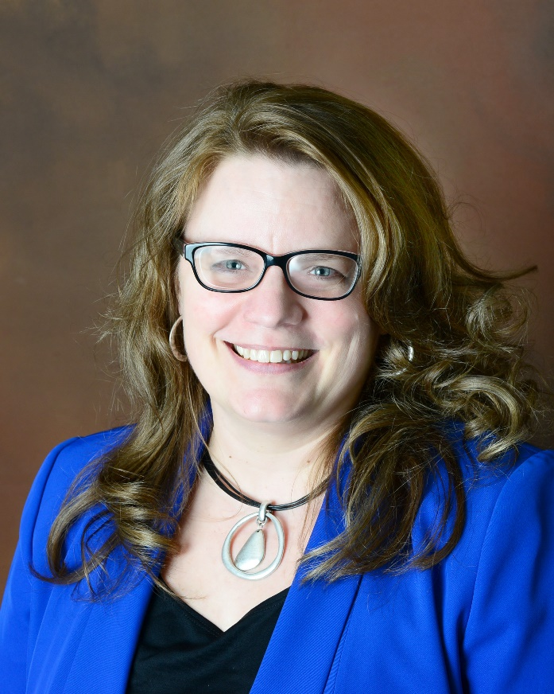

Lisa Shimkat, MBA, CBA
America’s SBDC Iowa State Director

Press Contacts:
Brianna Hall, America’s SBDC Iowa, 515-294-2030, bschwind@iastate.edu
Lisa Shimkat, America’s SBDC Iowa, 515-294-2030, lshimkat@iastate.edu

##

