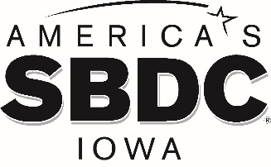

**FOR IMMEDIATE RELEASE**

**America’s SBDC Iowa’s Michael Wampler Becomes Certified Global Business Professional**

***Regional Director at Northwest Iowa SBDC hosted by Iowa Lakes Community College Becomes CBGP®***

AMES, Iowa - America’s SBDC Iowa (SBDC) is pleased to announce that Michael Wampler, Regional Director of the Northwest Iowa SBDC hosted by Iowa Lakes Community College, Spencer, has achieved certification in the Certified Global Business Professional® (CGBP) program.

The CGBP® program, developed by NASBITE International, confirms knowledge in international trade. The designation shows employers and the public that the individual is proficient in global business and capable of working with the level of expertise and professionalism that is required in today’s competitive environment.

Wampler has been counseling businesses in Clay, Dickinson, Emmet, Kossuth, Lyon, O’Brien, Osceola, Palo Alto and Sioux counties since July 2017.

Lisa Shimkat, State Director, America’s SBDC Iowa, says, “Michael is a valuable member of our statewide team. He is dedicated to giving his SBDC clients sound business advice and connecting them with resources they need to succeed. This certification is challenging to obtain and will provide Michael with additional knowledge that he can pass along to benefit those he advises.”

America’s SBDC Iowa is an outreach program of Iowa State University’s Ivy College of Business and the Office of Economic Development and Industry Relations. Iowa State University does not discriminate on the basis of race, color, age, ethnicity, religion, national origin, pregnancy, sexual orientation, gender identity, genetic information, sex, marital status, disability, or status as a U.S. Veteran. Inquiries regarding non-discrimination policies may be directed to the Office of Equal Opportunity, 3410 Beardshear Hall, 515 Morrill Road, Ames, Iowa 50011, Tel. 515-294-7612, Hotline 515-294-1222, email [eooffice@iastate.edu](mailto:eooffice@mail.iastate.edu).

Funded in part through a cooperative agreement with the U.S. Small Business Administration, America’s SBDC Iowa has 15 regional assistance centers located strategically across the state. Since program inception in 1981, the SBDC has helped Iowa businesses and entrepreneurs through no fee, confidential, customized, professional business counseling and practical, affordable training workshops.

For more information on America’s SBDC Iowa programs or services, call (515) 294-2030 or visit [www.iowasbdc.org](http://www.iowasbdc.org) or [www.facebook.com/AmericasSBDCIowa](http://www.facebook.com/AmericasSBDCIowa).

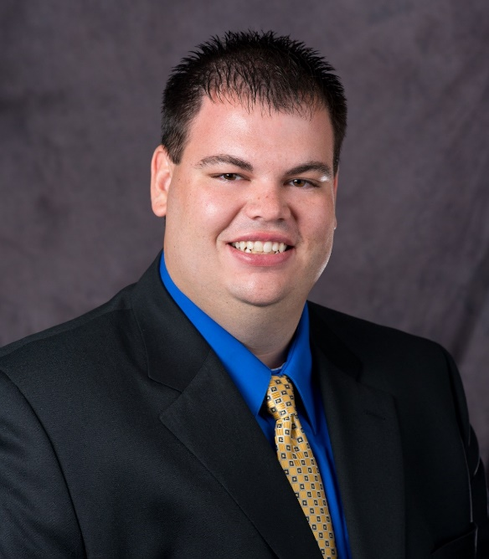

Michael Wampler, CBA

Northwest Iowa SBDC Regional Director

**Press Contacts:**

Brianna Hall, America’s SBDC Iowa, 515-294- 2030, [bschwind@iastate.edu](mailto:bschwind@iastate.edu)

Lisa Shimkat, America’s SBDC Iowa, 515-294-2030, [lshimkat@iastate.edu](mailto:lshimkat@iastate.edu)

###